

**MANUKAU INSTITUTE OF TECHNOLOGY**

Faculty of Business and Information Technology

**PROJECT PROPOSAL**

**Driver Safety & Drowsiness Detection System**

|  |  |  |
| --- | --- | --- |
| **Module** | : | **Hot Topic in Software** |
| **Supervisor** | : | **Fadi Fayez** |
| **Date of submission** | : | **28th May 2018** |
| **Team Members** | : | **Wijekoon Somasiri (170001510)**  **Herath Premarathne (170001825)** |
| **Emails** | : | [soma48@manukaumail.com](mailto:soma48@manukaumail.com)  [prem26@manukaumail.com](mailto:prem26@manukaumail.com) |

# TABLE OF CONTENTS

TABLE OF CONTENTS i

LIST OF TABLES ii

TABLE OF FIGURES iii

1. INTRODUCTION 1

1.1 Problem Description 1

1.2 Solution & Research Question 1

1.3 Scope 1

1.3.1 Aim of the project 2

1.3.2 Objectives of the project 2

1.3.3 Project Deliverables 2

1.4 Measurable Organizational Value 2

2. LITERATURE REVIEW 3

2.1 Overview 3

2.2 Existing Systems 3

2.2.1 StopSleep - Electronic Anti-Sleep Alarm 3

2.2.2 Bosch Driver Drowsiness Detection 3

2.2.3 Anti Sleep Pilot 4

2.2.4 Lane Departure Warning System 4

2.2.5 Drowsiness Detection system using EEG Helmets 5

2.2.6 Tesla Auto Pilot 5

3. SOFTWARE DEVELOPMENT METHODOLOGY 7

4. RISK MANAGEMENT 9

4.1 Identification of risks associated with the proposed project 9

4.2 Risk Mitigation 10

REFERENCES 11

# LIST OF TABLES

Table 1: Risk Mitigation 10

# TABLE OF FIGURES

Figure 1: StopSleep Alarm 3

Figure 2: Bosch Driver Drowsiness Detection 3

Figure 3: Anti Sleep Pilot 4

Figure 4: Standard Lane Departure warning Light on Dashboard 4

Figure 5: Vertical EEG recording from awake and drowsy condition (Kircher, 2001) 5

Figure 6: EEG Helmet 5

Figure 7: Tesla Auto Pilot 5

Figure 8: Agile Methodology 7

# 1. INTRODUCTION

## 1.1 Problem Description

Automobile has become a major part in our lives. They are used for transportation of people, items and any many other from one place to another. Whatever the automobile type (car, van, bike etc.) is being used for transportation, the safety should be a number one priority. While transporting people or any other item we should think about the safety of the passengers of the vehicle, public and private and public properties. According to Ministry of Transport, New Zealand (2018) number of road deaths has been increased from 284 to 393 within the period of 2011 to 2018. They also state that the number of reported injuries in transportation has amplified from 11,000 to 13,000 within a period of 5 years until 2017. Above statistics confirms that there should be a lot of improvements in the automobile and transportation industry for safety and the wellbeing of humans as well as the safety of private and public property.

There are various factors which contributes to road injuries and deaths. Some of them are lost control of the vehicle, speeding, alcohol, driver drowsiness, weather conditions, vehicle conditions and so on (Ministry of Transport New Zealand, 2018). Most of the time drivers do not care about the state of themselves prior to driving a vehicle. Even though the driver is tired, sleepy or has consumed alcohol he/she tries to drive a vehicle without any anxiety. As a result, it causes road accidents, injuries, loss of lives and damage to property. There aren’t many systems which could predict the conditions of the driver prior to a trivial incident which could assist the driver immensely. Therefore, this project mainly focuses on the driver drowsiness and how it can be identified using computer vision and facial features in order to provide necessary alerts to the driver when required as a warning, so that the driver can decide whether to continue driving or not and take a proactive approach to such incidents rather than a reactive approach.

## 1.2 Solution & Research Question

Since the road safety is the main priority, most of the high-end vehicle manufacturers implement safety systems in their vehicles. Unfortunately, these vehicles are expensive and most of the people can’t afford to buy them. Therefore, our research questions focus on improving the automobile safety practices using computer vision and low-cost hardware and improving the automobile safety practices by monitoring facial gestures of human.

The proposed solution will be implemented using image processing, computer vision and facial recognition techniques to increase the efficiency and the accuracy of the system. A camera will be the main hardware device to capture images of the eyes and this will reduce the cost of other expensive hardware devices such as embedded sensors and chips.

## 1.3 Scope

Proposed driver safety and drowsiness detection system will be a desktop application at its first stage as a prototype. In this system, a web camera will be used, and it will be placed in front of the driver (user) to capture images of the driver’s face and eyes. Simultaneously, the camera will provide live stream data (image frames) to the application to process them with face recognition and image processing techniques. By this process of execution, the system will detect the status of the eye (open eye or close eye) and alert the driver according to the eye status. The application will monitor image frames per second and identify the state of the eye. If the number of frames within the given period of time has more closed eye states compared to opened eye state, the system will provide warning alerts to the driver via a sound.

### 1.3.1 Aim of the project

The aim of this proposed system is to develop user-friendly, efficient, accurate and low-cost application using image and video processing algorithms to detect driver drowsiness to reduce road accidents and increase driver safety.

### 1.3.2 Objectives of the project

1. Research on the identified areas relevant to the project and come up with the literature review. The literature review of the project consists of existing driver safety systems and its functionalities along with the comparison table of the existing systems.
2. Design the system architecture according to the gathered information from the research.
3. Implement the finalized design of the proposed system.
4. Test and evaluate the implemented system.
5. Submit the deliverables on time.

### 1.3.3 Project Deliverables

* Research project proposal template
* Final research project proposal
* Final project report
* Prototype of the system

## 1.4 Measurable Organizational Value

Proposed solution of this project covers three main measurable organizational values. They are social, customer and financial aspects. As mentioned above in the solution and research question section majority of the population cannot afford to buy a high-end vehicle just for road safety purposes. Therefore, by implementing such a proposed system with low cost hardware will open up the opportunity for a vast number of customers. Customers could integrate the proposed system to their vehicles at a low cost compared to systems with sensors and chips. We expect the proposed solution to reduce the number of road accidents by 20 percent in the first year of installation to vehicles in New Zealand which will impact the society immensely. Team expects to take at least 500 customers aboard to the proposed system within the first year and growing the customer base by 10 percent each year. Customers will be attracted to the proposed solution since it is low-cost and the team can increase revenue and make a profit by new installations and maintenance of the proposed system. Since this application is a safety application for transportation it will have a great impact on our society. Not just the driver but also the passengers, public and property will be safe during transportation.

# 2. LITERATURE REVIEW

## 2.1 Overview

Studying existing similar systems is a key aspect of this project. It’s because we can learn those existing solutions and figure out what are the pros and cons of various systems. This will also help us improve some functionality of a system when added to this proposed project or may be add a whole new feature to our system which doesn’t exist in other similar systems. This will be an added value of the proposed system. Each member of the team has analyzed three similar systems. Since these systems are mostly hardware systems and not software systems the exact functionalities couldn’t be tested. But relevant information was extracted from internet sources related those products to come up with the literature review of the existing systems. We have explained our findings in the below section and have done a comparison and contrast of the chosen systems to better analyze the current situation in the automobile industry and driver safety & drowsiness detection systems.

## 2.2 Existing Systems

### 2.2.1 StopSleep - Electronic Anti-Sleep Alarm

According to StopSleep (2017) the aim of the unit is to prevent drivers falling asleep. Being a portable device, it is made to wear on two fingers like a ring. The device alerts through vibration, light and sound. All the device elements are made of cosmetics which are unlikely to cause any allergies including durable plastic. The StopSleep unit has 8 built-in measuring sensors to monitor the heat change of the skin. This system uses the same technology used in lie detector polygraphs. This system generates two types of warnings. They are attention and danger levels. The unit will vibrate in attention warning type while providing vibrations and loud sound in danger situations.

Figure 1: StopSleep Alarm

Use of StopSleep – electronic anti-sleep alarm is not hard. First the user has to power on the unit and wait until the sound and light appears. Once this is completed the user can wear the device in two fingers of a hand. Then the sensors will start monitoring for active, micro-sleep and sleep states of a human body and issues the warnings or alarms. The device needs to be charged and it can hold up-to 15 hours within a single charging session (StopSleep, 2017). Stop sleep wearable device can be purchased at around 200 US dollars (Amazon, 2018).

### 2.2.2 Bosch Driver Drowsiness Detection

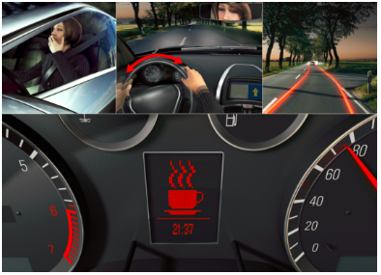Bosch driver drowsiness detection system monitors the steering patterns of a driver and predicts the fatigue and micro sleepiness of a driver. It evaluates and processes about 70 signals to understand the level of drowsiness of a driver. Bosch uses a steering-angle sensor to determine the steering angle and its velocity. The algorithm behinds the Bosch system starts monitoring steering patterns when a trip begins. It monitors for different parameters such as unexpected steering movements, use of signals and many others to identify the fatigue condition of the driver and when it reaches a certain level it informs the driver that he/she requires a rest by flashing a coffee cup sign in the system. This unit is also a part of a car’s anti-skid system which help the wheels of the vehicle to keep tractive contact with the road surface (Bosch China, 2012).

Figure 2: Bosch Driver Drowsiness Detection

### 2.2.3 Anti Sleep Pilot

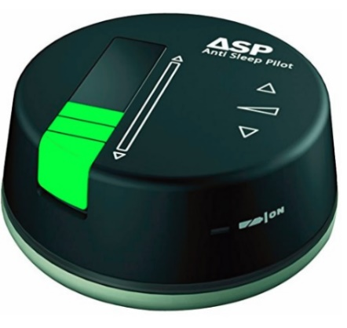Anti sleep pilot is a device which was developed by ASP Technology Ltd, Denmark. It is usually placed on the dashboard of a vehicle to continuously monitor the driver and his/her driving conditions. The device has a light sensor, a sound sensor and a touch sensor and operated using battery power. Initially the driver has to complete an assessment in order to create his/her risk profile. Once this is completed the driver can start using the device. It will automatically start monitoring the driver’s fatigue level using 26 parameters including the risk profile. The device conducts random tests so that the driver needs to tap on the device to response to those tests. If the response time is slow the driver will have a slow response time and continuous low response time will warn the driver to take at least a ten-minute break before driving the vehicle again. Anti sleep pilot device also monitors the time and speed of the vehicle, so it can determine the time that the driver actually had the break. This device costs around 250 US dollars (Coxworth, 2011; Asp Technology, 2018).

Figure 3: Anti Sleep Pilot

### 2.2.4 Lane Departure Warning System

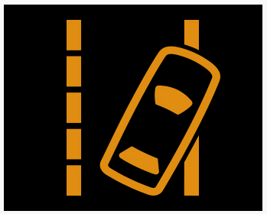

In early 2000, Mercedes Benz has invented first lane departure warning system for their heavy duty Actros trucks. After that most of the leading vehicle manufacturers implemented these kinds of systems for their vehicles.

Basically, lane departure warning systems alert the driver when the vehicle drift out of the lane. Nowadays, most of these lane departure warning systems are coming from different technologies of alerting the driver but with the same scenario. Most of the vehicle manufacturers have used low cost cameras mounted in the rear-view mirror which continuously keeps track of the solid lane marks ahead. If the vehicle drifts away from the lane most of the systems alerts the driver by giving visual warning with a beep sound. In advance, some systems vibrate the steering wheel and apply slight steering to the steering wheel to keep the vehicle on track (Driving Test Resource NZ, 2018).

Figure 4: Standard Lane Departure warning Light on Dashboard

Most of the high-end vehicle manufacturers have implemented these systems with new technologies such as adaptive cruise control and forward collision warning to project the vehicle in front, lane departure warning to project the vehicle by the side and blind spot detection to project the vehicle behind. These systems cost more than 1000 US dollars and only implemented in high-end vehicles. (Howard, 2017)

### 2.2.5 Drowsiness Detection system using EEG Helmets

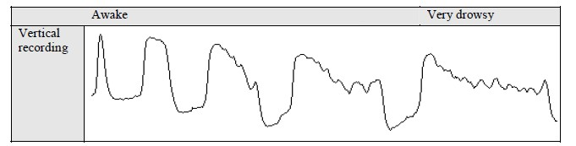

Figure 5: Vertical EEG recording from awake and drowsy condition (Kircher, 2001)

Physiological measures are most common and effective detectors when it comes to drowsiness detection. Electroencephalogram (EEG) is considered as the most reliable physiological method to detect drowsiness. EEG consists of a method to measure and record the electrical activity of the brain using electrodes placed on the scalp.

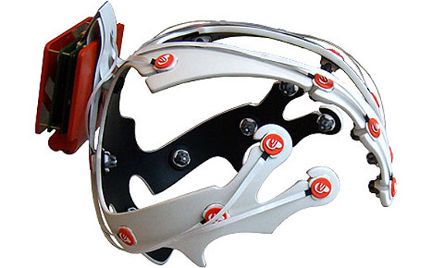In this kind of driver safety and drowsiness detection system driver has to wear an EEG electrode mounted helmet to detect the drowsiness. These EEG electrodes detect the rays of the brain. Basically, if these electrodes detect alpha activity of the brain that will become the first indicator of the drowsiness. So, the system alerts the driver by making a sound or vibrating the steering wheel. Above figure 5 shows the changes between awake to drowsiness mode. (Awasis, 2016)

Some people do not show any alpha activity even thou he/she in drowsiness mode. To detect this situation EEG helmets should detect theta activity of those people. Therefore, these helmets are considered as high cost driver safety system (Gottlieb, 2004).

Figure 6: EEG Helmet

### 2.2.6 Tesla Auto Pilot

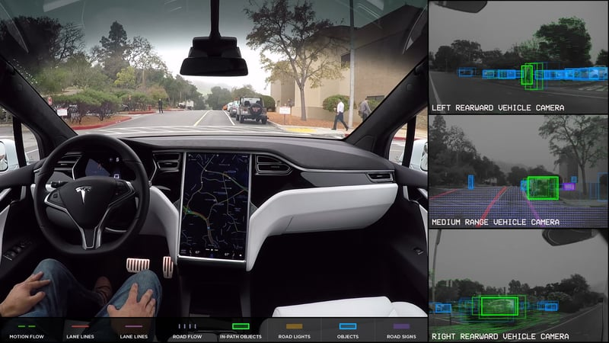

Figure 7: Tesla Auto Pilot

Tesla auto pilot driver safety system was implemented by Tesla Motors for their vehicles in 2014. This system consists of eight cameras mounted around the vehicle to get 360 degrees visibility up to 250 meters of range. Also, twelve updated ultrasonic sensors for detection of both hard and soft obstacles around the 250-meter range. In addition, a forward-facing radar is providing other data around the car such as rain, fog and dust. Computer process in the vehicle controls the car without human involvement if there is any mistake done by the driver with the assistance of the collected data from the cameras and sensors. This system is an advanced system compared to most of the driver safety systems. Tesla auto pilot model S and X are available in the market for customers and it costs around 80,000 US dollars. (Tesla Inc, 2018).

## 2.3 Comparison of Existing Systems

|  |  |  |  |  |  |  |
| --- | --- | --- | --- | --- | --- | --- |
| **Existing Systems** | **StopSleep - Electronic Anti-Sleep Alarm** | **Bosch Driver Drowsiness Detection** | **Anti Sleep Pilot** | **Lane Departure Warning System** | **Drowsiness Detection system using EEG Helmets** | **Tesla Auto Pilot** |
| **Developed by** | StopSleep Anti-Sleep Alarm PLC | Bosch Germany | ASP Technology Ltd, Denmark | Mercedes Benz | Ford Motor company | Tesla Inc. |
| **Detection method** | Skin heat | Steering patterns | Driver responds vehicle speed | Lane boundaries | Alpha activity of human brain | Monitor obstacles around the vehicle |
| **Hardware devices** | Eight sensors | Steering angle sensors | Light. Sound and touch sensors | Camera | EEG electrode mounted helmet | Eight cameras and twelve ultrasonic sensors |
| **Device Status** | Portable | Not Portable | Not Portable | Not Portable | Portable | Not Wearable |
| **Alerting Method** | Vibrating the device , light and sound | Flashing a coffee cup sign in the system | Sound | Virtual warning with beep sound | Vibrating the steering wheel with a sound | Control the car without human involvement |
| **Market Price** | 200 USD | - | 250 USD | 1000 USD and above | 500 – 1000 USD | 80000 USD |

Table 1: Comparison of Existing Systems

## 2.4 Justification and Conclusion

Literature research has focused on many existing systems and most of the systems have common functionalities. Among them literature research moved forward on six different existing driver warning systems which listed out above.

StopSleep electronic anti alarm system seems to be a good existing system since it’s a portable device and can afford for 200 USD. This system uses skin heat of the driver to detect the driver’s status and that seems to be a different approach compared to other systems. When it comes for its functionalities driver must wear this device to his/her fingers. After that sensors will start monitoring for active, micro-sleep and sleep states of the driver and issuing warnings according to heat. Generally this systems seems to be a good system but there are some issues of this system when we investigate deeply. Human body temperature depends on various factors such as health conditions, weather and climate conditions. In that case there would be a doubt how the system actually detect the state of the driver whether he/she can drive the vehicle. Also this device is portable and driver must wear the device in to fingers. This can be annoying and distracting the driver. In long distance driving these sensors can be demise because of the perspiration and low battery power. Therefore this systems is not that much accurate to use as driver safety system at all the times.

Bosch driver drowsiness detection system is one of the other existing systems which monitor steering wheel patterns to detect driver drowsiness. Bosch has used steering-angle sensor to determine the steering angle and its velocity. If there are any unwanted steering wheel movements the system will alerting the driver by flashing a coffee cup sign light in the system dashboard. Rather than analyzing only the steering movements it’s better to analyze the steering movement with the lane boundaries. Unfortunately this system doesn’t consist of any sensor to detect lane marks on the road. Moreover the system will alert the drive by flashing a light on the dashboard and this won’t be good solution to alert the driver because driver can’t see any lights when he/she is in drowsiness situations. Therefor driver can’t rely on this system.

Anti Pilot is another driver safety system which consists of light, sound and touch sensors. This system monitors the driver and makes random test to the driver and driver needs to tap the device within a certain time period. If the respond time is too long the system alerts the driver by making a sound. Generally seems to be fine since the system try to keep the driver wake up. But tap the device when driving is a risk and it distract the driver from the driving. Therefor this system might increase road accidents instead reduce.

Mercedes Benz invented the lane departure warning system as a driver safety system in early 2000. In this system a mounted low cost camera will keep track on the road boundaries by tracking the road lines and alerting the driver if vehicle drift out the lane. But system get confused when there are many lines on the road. Also this system monitor the boundaries of the road by tracking the road lines so this system doesn’t have any capability of monitor road boundaries without line such as in gravel roads. Moreover this system doesn’t have any way to monitor the road lines in rain, fog and snow situations. In this case driver can’t depend on the system safety.

EEG helmets are more effective to detect drowsiness compared to other ways. In this type of system driver need to wear the EEG helmet to drive the vehicle. This helmets consist of EEG electrodes and these electrodes detect the alpha rays of the human brain and alerting the driver accordingly. Therefore this system is one of the best systems for detect driver drowsiness. But wearing a helmet while driving make the driver uncomfortable and annoying. In addition, long time driving would result in perspiration on the EEG electrodes and, reduce the ability of monitoring drowsiness. Also these helmets are very expensive to afford. Moreover People who doesn’t show any alpha activity must afford to buy a helmet with EEG theta ray detect electrodes. Therefore these helmets are considered as high cost driver safety system.

Tesla auto pilot driver safety system consists of eight cameras and twelve ultrasonic sensors to detect all the hard and soft obstacles around the vehicle. The system will collect all the data and control the car without any human involvement. Therefore this system is more powerful and effective when it comes to the driver safety. This system is seems to be the most expensive driver safety system among all the existing systems which cost 80000 USD per month. So low end vehicle users can’t afford for this type of driver safety system.

Taking into considering all the facts about existing systems our proposed driver safety and drowsiness detection system is targeting all the low end vehicle users who can’t afford expensive systems. Therefore the proposed system will use a camera to get a live video stream of the driver. This camera will mount inside the vehicle and no need to worry about rain, fog and any climate changes. This system will detect drowsiness though human eye open closure detection because driver must open his/her eyes to drive a vehicle. The system will alert the driver by providing beep sound if the driver is not in a good condition to drive. Therefore this system is simple and affordable to any user compared to all existing systems.

# 3. SOFTWARE DEVELOPMENT METHODOLOGY

The software development methodology we have chosen to progress with this proposed project is Agile. According to cPrime (n.d.) “Agile software development refers to a group of software development methodologies based on iterative development, where requirements and solutions evolve through collaboration between self-organizing cross-functional teams.” In simple words Agile supports to rapid changes in software development unlike other software development methodologies such as waterfall, prototyping etc. The user-requirements can always change and Agile accepts these changes from clients after promoting them via a disciplined project management process which is also called as Agile methods.

According to agilemanifesto (2001), Agile methodology values;

1. Individuals and interactions over processes and tools
2. Working software over comprehensive documentation
3. Customer collaboration over contract negotiation
4. Responding to change rather than following a plan

Since the proposed driver safety and drowsiness detection system is solely based on research, it could stream continuous requirements into the solution. Also, the technologies used in the proposed system are new to the team members. This will allow the members to have more interactions and collaborations in order to come up with a working software since a working prototype is a requirement of this project. Nevertheless, coming up with small deliverable features and continuous improvements as mentioned in Agile methodology will be a good idea over providing a whole complete functionality at once. Taking all the above factors into consideration and the project closely aligns with the above mentioned Agile values, “Agile” was chosen as the software methodology for the proposed project.

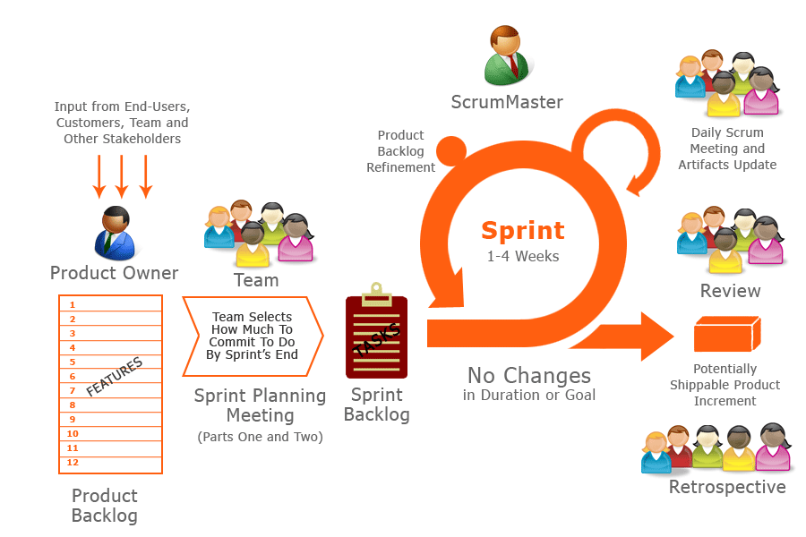

Figure 8: Agile Methodology

According to sinnaps (2018) there are 6 phases in the agile methodology. They are concept, inception, iteration/construction, release, production and retirement. Below is a list of activities done in each phase of the proposed project and we will be ignoring the last two phases (product and retirement) since the proposed system will not be production ready at the end of the project.

1. **Concept phase**

* Identifying the actual problem and the reasons behind the existing problem in the Automobile industry
* Identify the research question(s)
* Carry out research on existing solutions/applications/systems
* Project risk identification
* Identification of project risk treatment
* Define the scope of the project

1. **Inception phase**

* Form the team
* Identify the strengths and weaknesses of individual team members
* Discussion of initial user requirements
* Estimate the time periods for the overall project

1. **Iteration/Construction phase**

* Identify the features to be added to the sprint cycle (Requirements gathering)
* Prioritize the tasks in the sprint
* Analyze and design feature
* Implement feature
* Parallel testing
* Review code
* Feedback

1. **Release phase**

* Quality testing
* Deliver incremental features
* Finalize the prototype of the proposed driver warning and drowsiness detection system

The Agile method which will be used in the proposed project is Extreme Programming (XP). This is mainly because it has features such as pre-planning, planning game (spikes), pair programming, testing and in cooperate new features or correct bugs soon compared to other software methodologies. Pre-planning is assisted via the concept of sprint planning. In the Sprint planning the team can decide on which tasks will the team members work before actual tasks. Since the team only has two members pair-programming concept in XP helps this project to move forward without any problems. The team can also perform testing on the developments tasks and always have a progress at the end of sprint cycles. At the end if there are bugs, errors or new client requirements team can include them in the next sprint cycle or in the same sprint cycle if pre-planned.

# 4. RISK MANAGEMENT

Risk management is a crucial process in any project. If the risks aren’t properly identified and treated, it will affect the whole project ending up with a project failure. Project failures will not only affect the project team. The companies will lose their clients, partners and other stakeholders and also will give a bad reputation to the team and the responsible organization. These will affect the upcoming projects and the teams/organizations will be financially unstable to carry out further processes on projects. Hence, the risks which are associated with the proposed project will be identified initially. Once the risks have been identified we will be discussing how the mitigate the risk so that those risks will not affect the overall progress of the proposed project.

## 4.1 Identification of risks associated with the proposed project

1. **Lack of experts/skilled people in the research areas such as computer vision and machine learning**

In the proposed project the main research areas are video processing, image processing, face and eye detection and compare datasets to provide warnings. These concepts are relatively new to both the team members and this project will require a lot of research in order to identify on how to capture face and eyes from a live video stream and identify the eye open and closure states of the driver. Hence, this is identified as a potential risk in our project.

1. **Time management and estimations can be inaccurate**

The time allocated for the whole project is 8 weeks. Within this 8-week period the team members have to make sure that the project deliverables are met within the deadlines. Since the proposed project has so much of research to be done and due to lack of expertise in the research areas, the time allocated for each task can consume more time than expected. This could affect the time of the following tasks and the resulting the project to fail.

1. **Continuous growth of the project scope and ambiguity of requirements**

So far in the proposed project we have identified our main research areas. They are video/image processing, face and eye detection and research on datasets. But when research continuously progresses, it could introduce new requirements and other concepts to the project which they team members wouldn’t have even thought of. This could be one of the major risks in the project which could affect the project immensely.

1. **Potential data loss as a result of technology failures**

Technology risk is unavoidable in a project like this. No one can predict what will happen in the next minute of time. The development workstations might crash. If it happens it will be a shocking loss to the team member as it will affect completion of the project as well as affecting the final grades of the hot topic in software module as a student.

1. **Communication and collaboration between team members**

Both the team members are in the final quarter of the study program. Therefore, along with the hot topic module team has to focus on the final year project (last quarter) as well. There could be instances where the members will focus more on the final year project. If the work is not properly balanced, less communication, less team collaboration and no support to each other will become a burden for a single member of the team or both the members. This will create extra pressure in the team and it will affect the final year project as well.

## 4.2 Risk Matrix

The numbering used in the section 4.1 will be used to uniquely identify the risks associated with the proposed project in the below risk matrix.

|  |  |  |  |  |  |  |
| --- | --- | --- | --- | --- | --- | --- |
| ***RISK IMPACT*** | ***Severe*** |  | **4** | **2** | **3** | **1** |
| ***Significant*** |  | **5** |  |  |  |
| ***Moderate*** |  |  |  |  |  |
| ***Minor*** |  |  |  |  |  |
| ***Minimal*** |  |  |  |  |  |
|  | ***Almost Never*** | ***Possible but unlikely*** | ***Possible*** | ***Highly likely*** | ***Almost certain*** |
| ***LIKELIHOOD OF RISK OCCURANCE*** | | | | | |

Table 1: Risk Matrix

|  |  |
| --- | --- |
| ***COLOUR*** | ***RISK SEVERITY*** |
|  | High risks |
|  | Moderate risks |

Table 2: Risk color codes

Risk 1,2,3 are the high impact risks in the proposed project while 4 and 5 are moderate risks. By the above risk matrix, we have identified the severity of each risk and impact if occurred and below shows the priority of the identified risks.

1. Lack of experts/skilled people in the research areas such as computer vision and machine learning
2. Continuous growth of the project scope and ambiguity of requirements
3. Time management and estimations can be inaccurate
4. Potential data loss as a result of technology failures
5. Communication and collaboration between team members

In the next section “Risk Mitigation” we discuss the ways on how the team can mitigate the risks in order to make this proposed project a success.

## 4.3 Risk Mitigation

Table 3: Risk Mitigation

|  |  |
| --- | --- |
| *IDENTIFIED RISKS* | *RISK MITIGATION* |
| Lack of experts/skilled people in the research areas such as computer vision and machine learning | * Read articles, research papers, online resources and other materials related to computer vision and machine learning concepts and familiarize with them. * Identify the exact computer vision and machine learning concepts required for the proposed project (Video processing, Image processing, Datasets, Face and eye detection). * Do online tutorials and practice development tasks in above identified areas. * Request supervisor assistance. |
| Continuous growth of the project scope and ambiguity of requirements | * Identify the project requirements at the initial phases of the project. * Identify the exact research areas for the proposed project. * Define the scope of the project. * Have frequent team meetings and consult supervisor for proper planning of the functionality of the system. |
| Time management and estimations can be inaccurate | * Identify all the tasks which needs to be executed in the proposed project. * Create a Gantt chart including various tasks, it’s allocated time durations, milestones and the task deadlines. * Conduct frequent team meetings to monitor, review project progress and make amendments if required. |
| Potential data loss as a result of technology failures | * Frequent commits of project related work to a remote repository such as GitHub. * Take frequent back-ups of the project work to an external hard drive/USB flash drive. |
| Communication and collaboration between team members | * Carry out frequent team meetings. * Monitor the progress of each team member using GitHub remote repository. * Identify the issues related to the proposed project which each team member currently faces and support them to overcome such situations. * Consult supervisor for assistance. |

# REFERENCES

Amazon. (2018). *Anti Sleep Alarm for Drivers. Warns up to 5 Minutes Before Drowsiness. Beep and Vibration Doze Alert. Car Truck Safety Driving Warning Device. Stay Awake Nap Detector Technology Alertness System*. Retrieved from https://www.amazon.com/Drivers-Drowsiness-Vibration-Technology-Alertness/dp/B00A33APOU

Asp Technology Ltd. (2018). *Anti Sleep Pilot.* Retrieved from https://www.amazon.co.uk/Asp-Technology-Ltd-ASP001-Sleep/dp/B005C3EC18

Awasis. (2016). *Driver Drowsiness Detection using EEG Power.* Retrieved from https://www.researchgate.net/publication/271481486_Driver_drowsiness_detection_using_EEG_power_spectrum_analysis

Howard, B. (2017). *How does lane departure warning work.* Retrieved from https://www.extremetech.com/extreme/165320-what-is-lane-departure-warning-and-how-does-it-work

Bosch China. (2012). *Preventing microsleep Bosch Driver Drowsiness Detection.* Retrieved from http://microsite.bosch.com.cn/life/en/invented-for-life/citizen/bosch-driver-drowsiness-detection.html

Coxworth, B. (2011). *Anti Sleep Pilot detects drowsy drivers.* Retrieved from https://newatlas.com/anti-sleep-pilot-monitors-driver-fatigue/17439/

Driving Test Resource New Zealand. (2018). *Technology to keep you driving in your lane: lane departure warning & lane keep assist.* Retrieved https://www.drivingtests.co.nz/resources/technology-to-keep-you-driving-in-your-lane-lane-departure-warning-lane-keep-assist/

Ministry of Transport New Zealand. (2018). *Monthly road crash statistics update – March 2018.* Retrieved from https://www.transport.govt.nz/resources/road-safety-resources/roadcrashstatistics/monthlyoverviewofcrashstatistics/monthly-road-crash-statistics-update-march-2018/

Sinapps. (2018). *AGILE PROJECT MANAGEMENT: THE SPRINT METHODOLOGY.* Retrieved from https://www.sinnaps.com/en/project-management-blog/agile-project-management-sprint-methodology

StopSleep Pty Ltd. (2017). *StopSleep – Electronic Anti-Sleep Alarm.* Retrieved from http://www.stopsleep.com.au/about-3/

Tesla Inc. (2018). *Advanced Sensor Coverage.* Retrieved from https://www.tesla.com/en_NZ/autopilot

http://knowledgeblob.com/agile/scrum-framework/